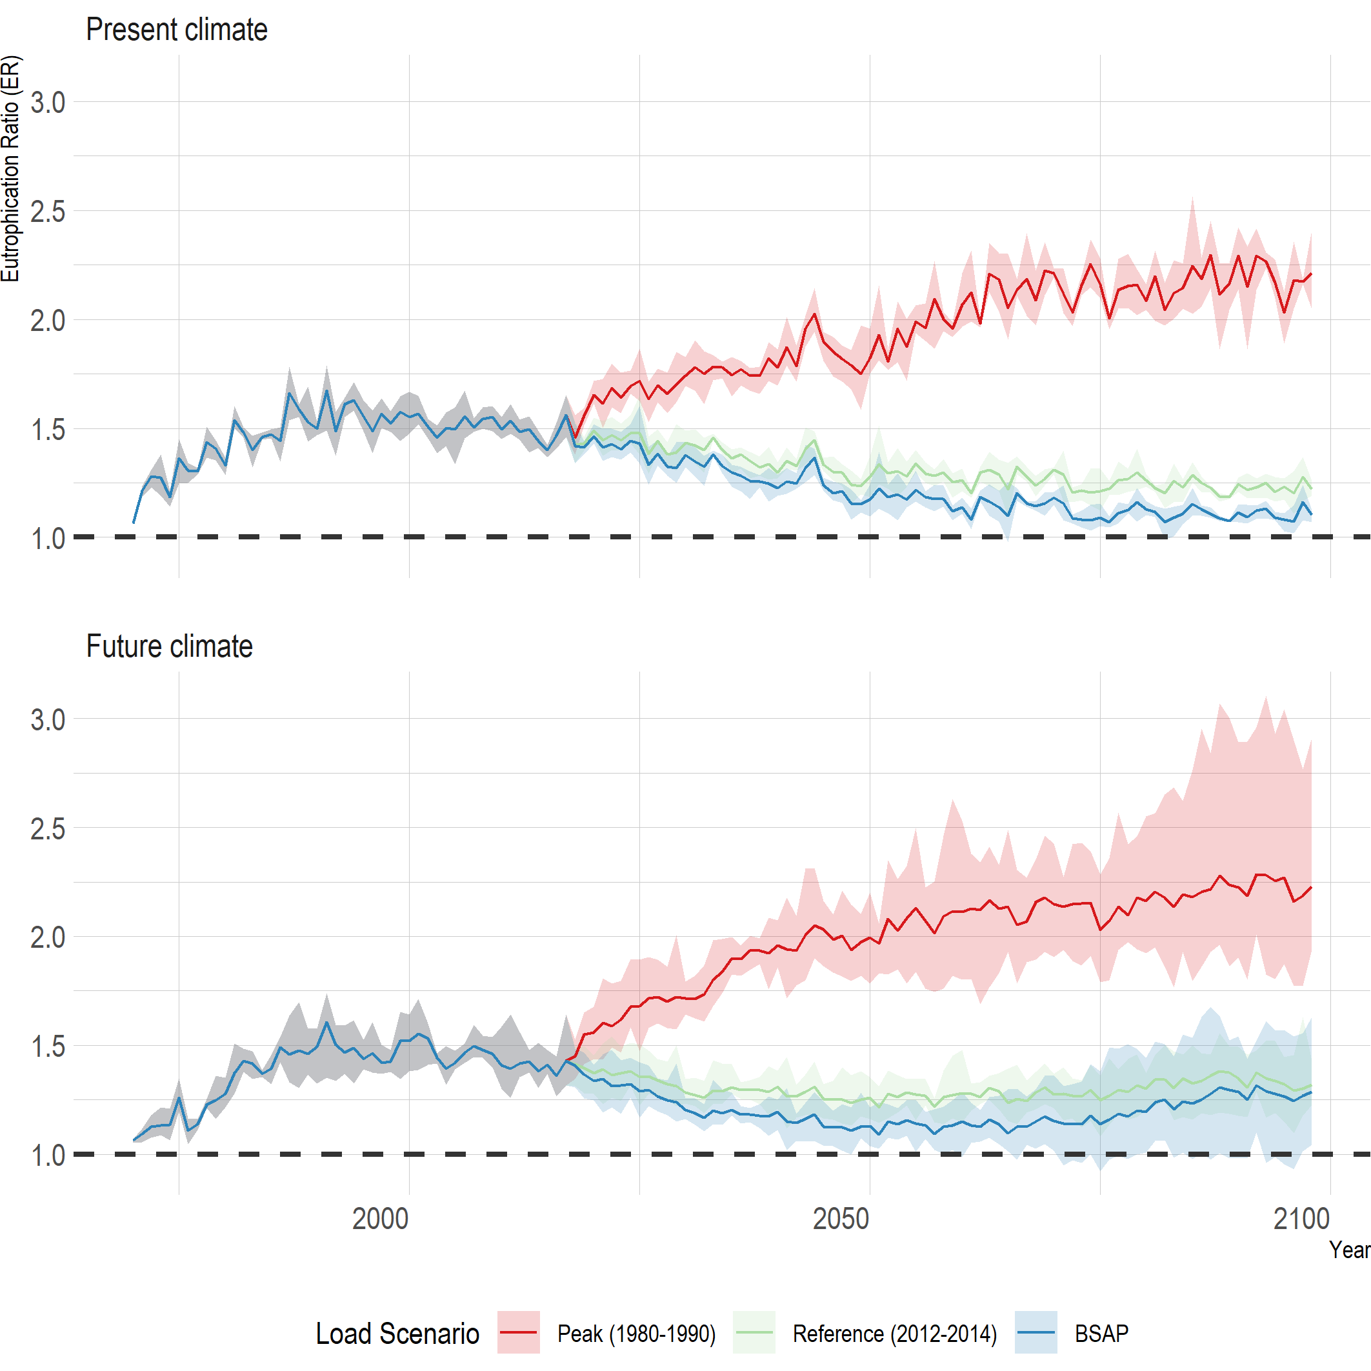

**Figure 1 - Baltic Sea Eutrophication Ratio (ER) for different load and climate scenarios**

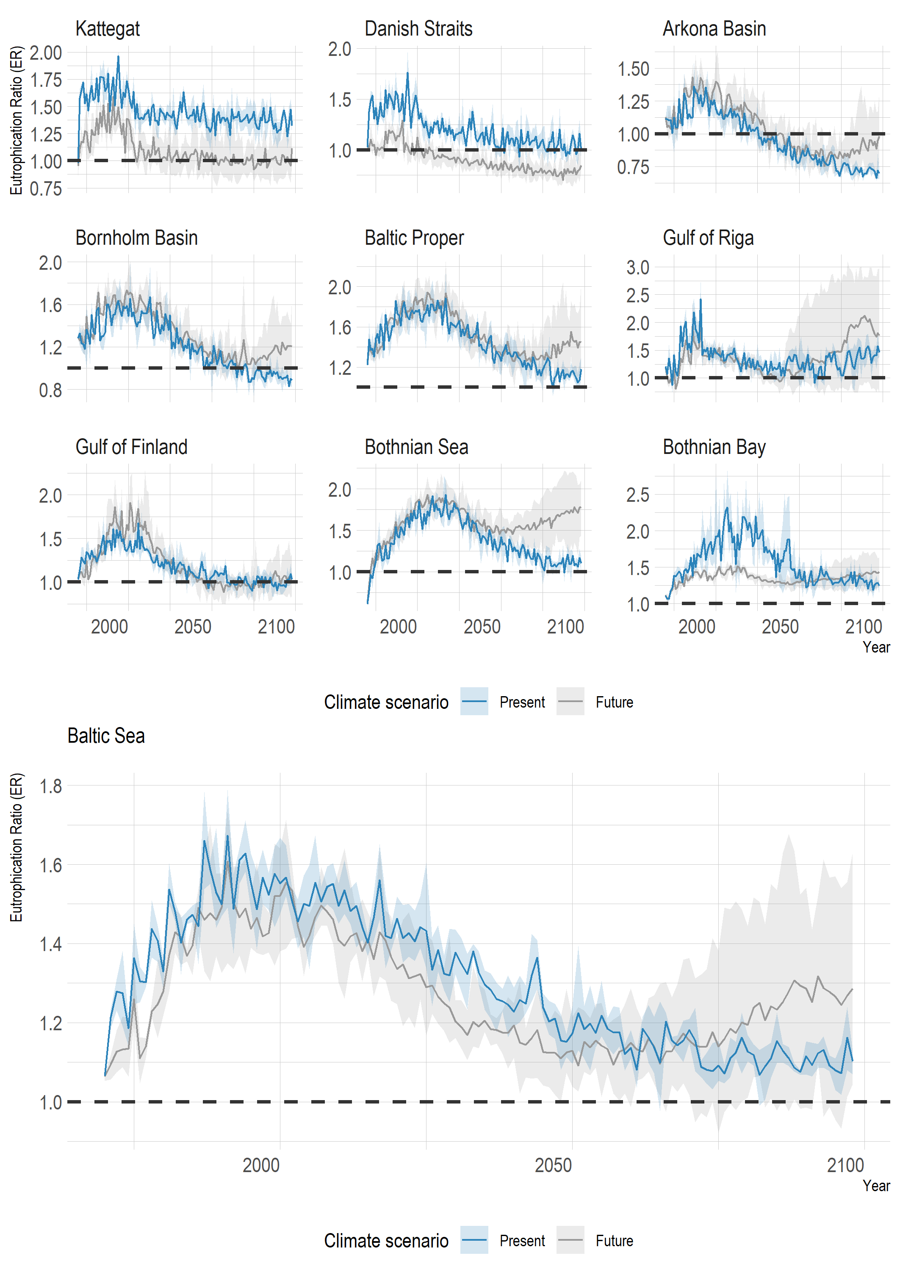

**Figure 2 - Comparing future climate vs. present climate for BSAP load scenario.**